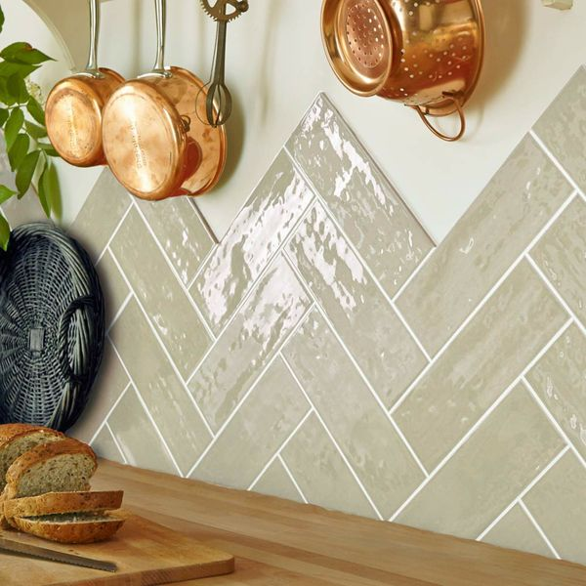**Almond Rustic Metro Tiles:**

## **Product DESCRIPTION**

Welcome the charming country look into your bathroom or kitchen this season with the introduction of these stylish Almond Gloss Tiles. They have a bumpy rustic surface, and are perfect for creating a kitchen splashback or a feature wall in a bathroom. They're made from ceramic, have a gloss finish, and belong to our range of Rustic Metro 30x10 Tiles. Their rustic design makes them ideal for injecting the traditional farmhouse look into your interior spaces. For an eye-catching finish, adopt a Herringbone layout. Want a closer look? Order a sample tile.

## **Product Info**

* Product ID: 15082
* Tiles Per SQM: 33.333333333333
* Sale by: Per SQM
* Size: 100x300x7mm
* Weight: 0.44 KG
* Material Type: Ceramic
* Finish: Gloss
* Colour: Beige/Ivory
* Suitability: Walls
* Grade: No
* Rectified Edge: No
* Underfloor Heating: No
* Thickness (mm): 7